- Text Messages
Characters can receive text messages. In a blueprint, on a Character actor, just call “Receive Text Message” with the appropriate inputs.
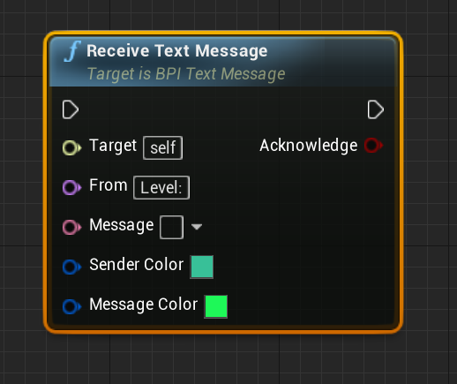
Mostly, the messages have no effect. But with a player character, the message is displayed on the Player’s HUD.

